EXPERIMENT – 1
Installation and Configuration of Kali Linux in Oracle VirtualBox

Aim
To install and configure Kali Linux as a virtual machine using Oracle VirtualBox for performing network security and ethical hacking experiments.

Software Requirements
- Host Operating System: Windows / Linux / macOS
- Virtualization Software: Oracle VirtualBox
- Guest Operating System: Kali Linux ● System Requirements:
o RAM: Minimum 4 GB (8 GB recommended) o Disk Space: Minimum 30 GB o Processor: Intel/AMD with Virtualization support
Introduction:
Kali Linux is a Debian-based Linux distribution developed for penetration testing, digital forensics, and cybersecurity analysis.
Installing Kali Linux inside Oracle VirtualBox provides a safe and isolated environment to practice security experiments without affecting the host system.
VirtualBox is an open-source virtualization tool that allows running multiple operating systems simultaneously on a single physical machine.

Procedure
Step 1: Enable Virtualization
- Restart the system and enter BIOS/UEFI settings.
- Enable Intel VT-x / AMD-V.
- Save changes and reboot the system.
Step 2: Install Oracle VirtualBox
- Download Oracle VirtualBox from the official website.
- Run the installer and follow default installation steps.
- Complete the installation and restart the system if required.
Step 3: Download Kali Linux
- Visit the official Kali Linux website.
- Download the Kali Linux Installer ISO (64-bit).
Step 4: Create a New Virtual Machine
- Open Oracle VirtualBox.
- Click New.
- Enter:
o Name: Kali Linux o Type: Linux o Version: Debian (64-bit)
- Click Next.
Step 5: Allocate Memory and CPU
● Memory Size: 2048 MB or higher ● Processor: 2 CPUs ● Click Next.
Step 6: Create Virtual Hard Disk
- Select Create a virtual hard disk now.
- Choose VDI (VirtualBox Disk Image).
- Select Dynamically allocated.
- Set disk size to 30 GB.
- Click Create.
Step 7: Attach Kali Linux ISO 1. Select the created VM → Settings.
- Go to Storage.
- Under Controller IDE, select Empty.
- Click Choose a disk file and select Kali Linux ISO.
- Click OK.
Step 8: Install Kali Linux 1. Start the virtual machine.
- Select Graphical Install.
- Choose: o Language o Location o Keyboard layout 4. Configure network automatically.
- Set:
  - Username o Password
- Choose:
  - Guided – Use entire disk o All files in one partition 7. Confirm disk changes and continue installation.
8. After completion, reboot the system.
Output: 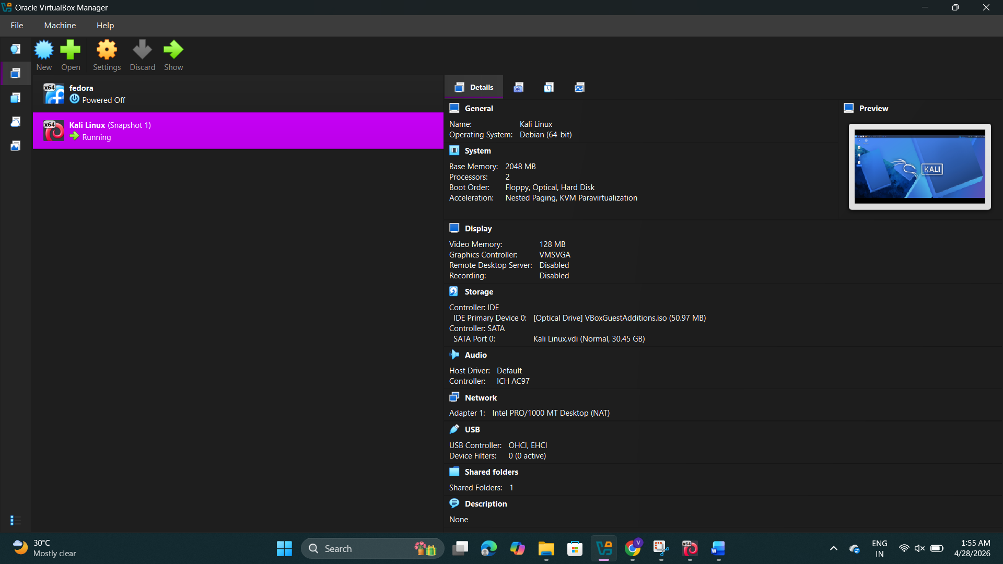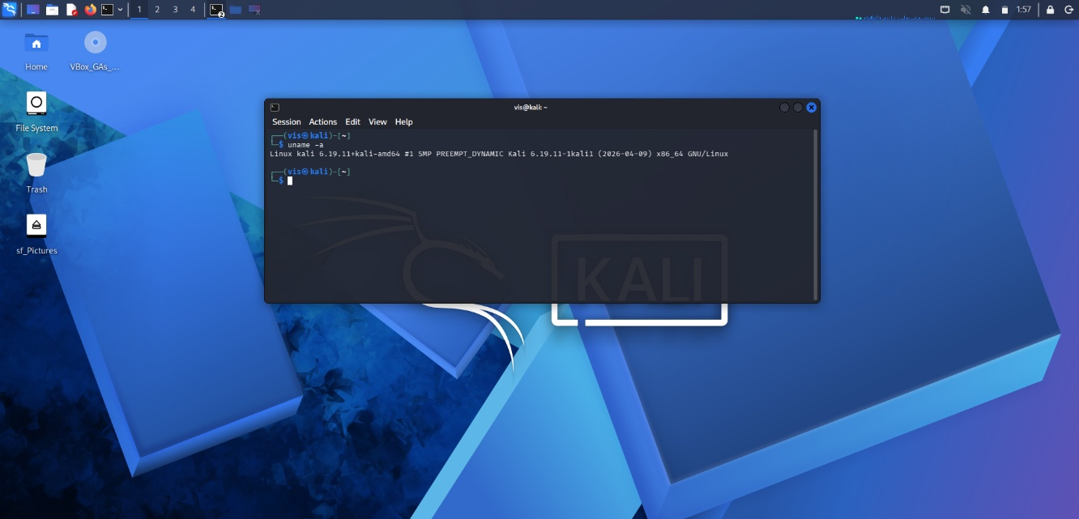

Result
Kali Linux was successfully installed and configured in Oracle VirtualBox. The virtual machine is ready for performing network security and ethical hacking experiments.

